|  |  |
| --- | --- |
|  | **Compiling STxP70**  **ISP Firmware** |

|  |  |
| --- | --- |
| Purpose | U8500 Compiling STxP70 ISP Firmware code |
| Document Status | Draft |
| Date | March 12, 2012 |
| Document  Version | V0.1 |

|  |  |  |  |
| --- | --- | --- | --- |
| Version | Release Date | Writer | Update |
| V0.1 |  | Chetan Nanda | Creation – Initial Draft |

Legal Information

**© Copyright ST-Ericsson, 2009. All Rights Reserved.**

**Disclaimer**

The contents of this document are subject to change without prior notice. ST-Ericsson makes no representation or warranty of any nature whatsoever (neither expressed nor implied) with respect to the matters addressed in this document, including but not limited to warranties of merchantability or fitness for a particular purpose, interpretability or interoperability or, against infringement of third party intellectual property rights, and in no event shall ST-Ericsson be liable to any party for any direct, indirect, incidental and or consequential damages and or loss whatsoever (including but not limited to monetary losses or loss of data), that might arise from the use of this document or the information in it.

ST-Ericsson and the ST-Ericsson logo is trademarks of the ST-Ericsson group of companies or used under a license from STMicroelectronics NV or Telefonaktiebolaget LM Ericsson.

All other names are the property of their respective owners.

**Trademark List**

All trademarks and registered trademarks are the property of their respective owners.

In addition to the generic statement above, please fill in all trademarks and registered trademarks that could be identified.

See examples below.

|  |  |
| --- | --- |
| *Microsoft®* | Microsoft is a registered trademark of Microsoft  Corporation in the United States and/or other  countries. |
| *OBEX™* | OBEX is a trademark of Infrared Data Association. |
| *Android™* | Android is a trademark of Google Inc*.* |
| *Ubuntu®* | Ubuntu is a registered trademark of Canonical. |
| *Sony®* | Sony is a registered trademark of Sony Corp. |

Table of Contents

1. References 4

2. Acronyms and Terms 5

2.1 Glossary 5

3. Introduction 6

3.1 Scope 6

3.3 Audience 6

4. Environment Setup 7

4.1 SW Environment 7

5. STxP70 Toolchain 8

5.1 Installation 8

5.2 ISP FW Compilation 8

5.2.1 Exporting Path variables 8

5.2.2 Launch / Build 9

6. Open Points 13

# 1. References

|  |  |  |  |  |
| --- | --- | --- | --- | --- |
| **Category** | **Title** | | **Version** | **Editors** |
| SW | /1/ | STE Imaging Software Development Doc | V1.0 | Chetan NANDA |
|  |  |  |  |  |

# 2. Acronyms and Terms

## 2.1 Glossary

|  |  |
| --- | --- |
| **Term** | **Definition** |
| 3A | AEC + AWB + AF |
| FW | Firmware |
| HREF | STE Reference Board |
| IRP | Image Reconstruction Pipe |
| ISL | Intelligent Status Line |
| ISP | Image Signal Processor |
| ITE | Integrated Test Environment |
| LLCD | Low Level Camera Driver |
| MMDSP | Multimedia DSP |
| MMTE | Multimedia Test Environment |
| NMF | Nomadik Multimedia Framework |
| OMX | OpenMax |
| RHEL | Redhat Enterprise Linux |
| SDK | Software Development Kit |
| SIA | Smart Imaging Accelerator |
| XP70 | Dedicated MCU |
|  |  |

# 3. Introduction

STE Imaging HW stack also called SIA contains an ‘Image Reconstruction Pipe’ (IRP)/ISP. It provides lots of Image processing features e.g.

* Support 8, 10, or 12 Bit data sensor
* Lens shading correction.
* Defect correction etc…

All ISP features are configured and controlled through ISP FW running on dedicated MCU i.e. STxP70.

This document provides details about installing STxP70 tool chain, compiling ISP FW.

## 3.1 Scope

This document covers the following:

* Installing STxP70 tool chain.
* Compiling ISP FW.

Integrating ISP FW binaries into Android is not covered in this document.

Refer /1/ for the same.

## 3.3 Audience

The audience of this document is limited to engineers/developers working STE ISP FW.

# 4. Environment Setup

STxP70 tool chain has been tested for RHEL3, RHEL4 and Ubuntu10.04.

## 4.1 SW Environment

Following are the SW requirements for installing STxP70 tool chain:

* A Linux machine with Ubuntu 10.04 / RHEL 4 or later.
* Python 2.4.3 on Linux machine. Needed for Pre/Post build scripts.
* STxP70 tool chain binary (Provided in SDK/Tools).

STxP70 tool chain provides a GUI based interface for compilation.

ISP FW compilation needs Python 2.4.3 or later to be present for pre and post build process. Python can be installed in /opt or any other location, $PATH variable needs to be updated accordingly.

# 5. STxP70 Toolchain

STxP70 tool chain binary is available as part of SDK at ‘*SDK/Tools/STxP70_Professional_Toolset_4_0_0.bin*’

### 5.1 Installation

ST Workbench installer is available in SDK and may need additional packages on Linux machine to recognize installer in ‘*.bin’* format.

Also one should have ‘*root’* permissions to install the software.

|  |
| --- |
| #ST Workbench installation   1. Change the permission of installer using following command   **$ chmod 0777 STxP70_Professional_Toolset_4_0_0.bin**   1. For installing tool run following command   $ ./ **STxP70_Professional_Toolset_4_0_0.bin**  STxP70 installer provide graphical interface for installing the toolset. Now follow the on-screen instruction to complete the installation process.  Double clicking the .bin file will also provide the UI where user can select the path where to install the toolset (e.g. /opt).  #Installing Python   1. By default Python is included in almost all version of Linux. Check for the installed version of Python using following command   **$ python -V**  **Note:**  Python version should be equal to or above v2.4.3. |

## 5.2 ISP FW Compilation

This section provides the steps for compiling ISP FW source code using ST Workbench installed using above steps.

Assuming the toolset is installed at ‘*/opt’* path.

### 5.2.1 Exporting Path variables

To launch newly installed STxP70 Workbench, we need to export/set some path variable as per installed path of toolset.

|  |
| --- |
| #Exporting/Setting path variables  SELECTED_PATH=/opt  export SELECTED_PATH  source $SELECTED_PATH/STM/STxP70_Toolset_4.0.0/bin/STxP70.sh  SX=$SELECTED_PATH/STM/STxP70_Toolset_4.0.0  export SX  STWORKBENCH=$SELECTED_PATH/STM/STxP70_Toolset_4.0.0/stworkbench  export STWORKBENCH |

### 5.2.2 Launch / Build

Go to installed location of STWorkbench and launch using following

*cd /opt/STM/STxP70_Toolset_4.0.0/stworkbench/*

*./stworkbench*

These commands will provide a GUI for setting up the workspace. This will open a window and user can select any folder for creating the workspace.

It is advisable to create a separate folder for the build and select it as the workspace

The following image displays how to set the workspace. The **<PATH>** can be replaced with the actual path containing the workspace.

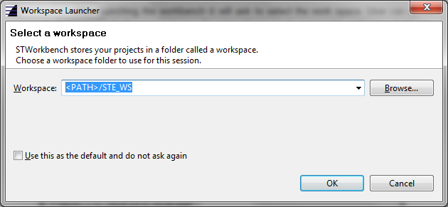

If the workspace is a newly created one, then we need to import existing ISP FW project into the workspace.

ISP FW project files are part of ISP FW release, this make it easy to import the FW directly into ST Workbench tool.

For importing a existing project select **‘File-> Import’** this will open following dialog box.

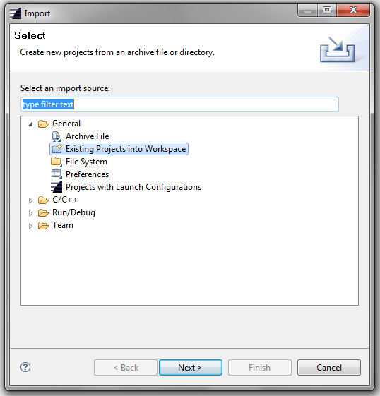

Select ‘**General->Existing Projects into Workspace’** option and click ‘**Next’** button. This will open following window

In the ‘**Select root directory**’ option, provide the path upto ‘**PictorProject**’ folder.

“**Copy projects into workspace**” check box at the bottom of the window can be checked to copy the whole folder structure of PictorProject to the workspace.

Click ‘**Next**’ button, this will a single entry under ‘**Projects**’.

Select this entry and click ‘**Finish**’ button.

After these steps, whole PictorProject will be imported to ST Workbench. ST Workbench is eclipse based tool and can be used modify/edit and compile the ISP FW source code.

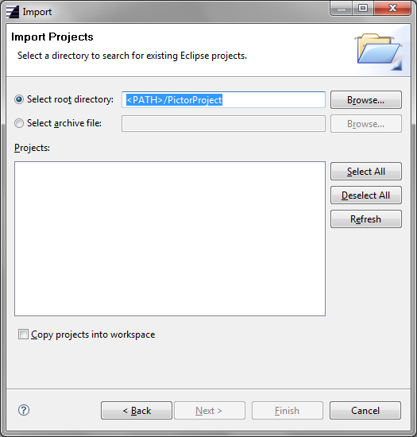

After the code is imported to the workspace, ST Workbench will show the PictorProject directory structure in left of Workbench as shown below

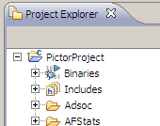

ISP FW can be build by selecting ‘**Project-> Build Project**’ menu option.

On successful build, ISP FW binaries would get created in ‘**isp_fw/Binaries’** folder.

It generates four binaries under ‘isp_fw\Binaries’:

* Isp8500_primary_fw_data.bin
* Isp8500_primary_fw_ext.bin
* Isp8500_primary_fw_ext_ddr.bin
* Isp8500_primary_fw_split.bin

Three headers file under ‘isp_fw\DeviceParams’:

* baseline.h
* extension.h
* nvm.h

These binaries then needs to be integrated in Android build process. Refer /1/ for further information.

# 6. Open Points

1. Steps to be verified against the latest environment.